ModTech International Conference - New face of TMCR
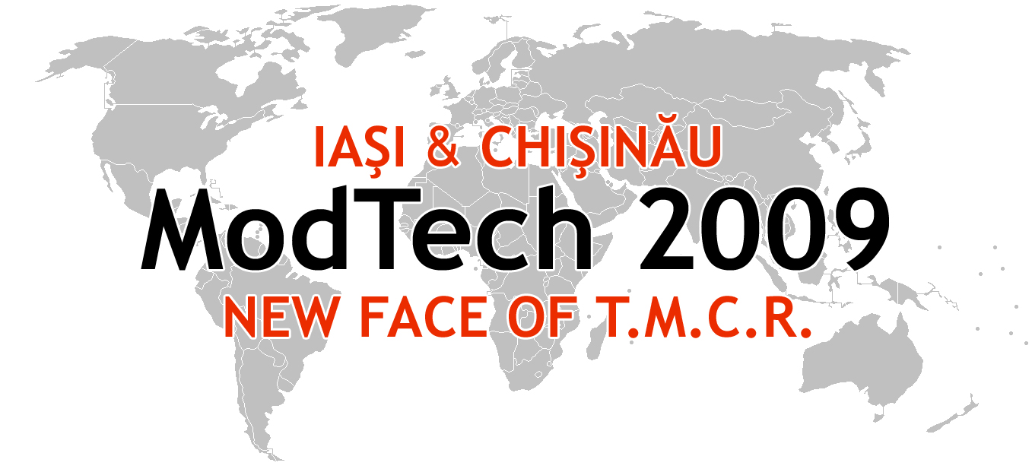

Modern Technologies, Quality and Innovation - New face of TMCR
21-23rd May 2009
http://www.modtech.ro

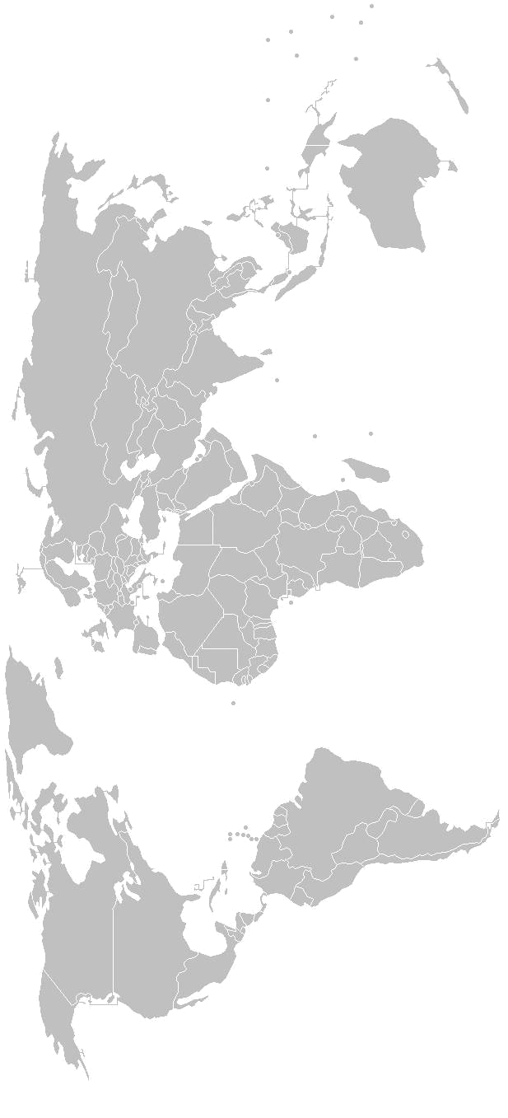
SECTION 3
Automation and Flexible Technologies

A-0-08, Laboratory of Flexible Manufacturing Technology

Chair: Prof. Petru Dusa, Ph.D.
Co-Chair: Assoc. Prof. Vasile Merticaru, Ph.D.
Secretary: Iustina Rotman, Ph.D. Student

Thursday  May 21 | Papers & Authors
15²⁰-15³⁵ | Reliability distribution applied to flexible components  Costel Bejan, Ioan Lihtetchi, Carol Ambrus
15³⁵-15⁵⁰ | Thermal calculation of the footwear outsoles made through injection in moulds  Elena Chirilã & Cornelia Ionescu Luca
15⁵⁰-16⁰⁵ | Thermal calculation of the footwear soles made through vulcanization in moulds  Elena Chirilã & Cornelia Ionescu Luca
16⁰⁵-16²⁰ | Monitoring the overall equipment effectiveness in an industrial process using data aquisition systems  Petru Dusa, Olivian Chitic, Valentin Lupu& Iustina Rotman
16²⁰-16³⁵ | Optimization of the flexible machine tools configuration for the technological process equipping  Aurel Costea, Nicoleta Rachieru, Raluca Magdalena Nita, Marin Gheorghe
16³⁵-16⁵⁰ | Modeling of the manufacturing systems competitiveness  Luiza Daschievici, Daniela Ghelase, Alexandru Epureanu & Constantin Falticeanu
16⁵⁰-17⁰⁵ | Integration of control and maintenance in machining process as an intermediary step  Eugen Pămîntaş & Felicia Veronica Banciu
17⁰⁵-17²⁰ | Theoretical and experimental study of torque damping in non linear elasticity couplings Venetia Sandu, Costel Bejan
17²⁰-17³⁵ | Design and manufacturing an abrasive flow machining equipment  Aurelian Vişan, Nicolae Ionescu, Valeriu Avramescu & Gheorghe Orăşanu
17³⁵-17⁵⁰ | Elimination techniques of microbiological agents in water purification processes with uv radiation  Cristinel Badea, Dumitru Nedelcu, Irina Volf
17⁵⁰-18⁰⁵ | Holistic approach on integrated, collaborative product design  Felicia Banciu, George Draghici & Cristian Gheorghe Turc
18⁰⁵-18²⁰ | Product design models, methods and tools knowledge synthesis  Banciu Felicia, George Drăghici and George Belgiu
Friday  May 22 | Papers & Authors
9⁰⁰-9¹⁵ | Integrated approach of the dimensional control in turning processes  Ionut Clementin Constantin, Alexandru Epureanu, Mihaela Banu, Vasile Marinescu & Florin Bogdan Marin
9¹⁵-9³⁰ | A method to approximate a spatial surface using a bézier bi-cubic surface  Mariana Drişcu
9³⁰-9⁴⁵ | Procedure for modeling experimental dates using the fourier function  Mariana Drişcu
9⁴⁵-10⁰⁰ | Holonic feedrate scheduling  Florin Bogdan Marin, Alexandru Epureanu, Mihaela Banu, Vasile Marinescu & Ionut Clementin Constantin
10⁰⁰-10¹⁵ | Intelligent fixing systems on multifunctional machine tools  Raluca Magdalena Nita, Stefan Craciunoiu, Valeriu Avramescu, Gheorghe Marin
10¹⁵-10³⁰ | Research into energy consumption and efficiency of bread processing units with focus on bread ovens  Cristina Maria Bica, Ana Maria Nazaru
10³⁰-10⁴⁵ | Influence of tool type insert on cutting force in machining of HDPE  Ana Munteanu, Catalin Fetecau

